

<**GWFP Salinity Drift**>

Control Number:<xxxx-xxxxx>

Version: 0-01

**Date: 2022-07-22**

**Authors: Andrew Reed, John Lund**

**Approver: <name>, <date>** [Remove this line if CCB approval required.]



Coastal and Global Scale Nodes

Ocean Observatories Initiative

Woods Hole Oceanographic Institution

Oregon State University

**Revision History**

|  |  |  |  |
| --- | --- | --- | --- |
| **Version** | **Description** | **ECR No.** | **Release Date** |
|  |  |  |  |
|  |  |  |  |
|  |  |  |  |
|  |  |  |  |

**Table of Contents**

**List of Figures i**

List of Tables i

1.0 Introduction 1

1.1. Scope 1

1.2. Purpose 1

1.3. Executive Summary 1

2.0 Reference Documents 1

3.0 Definitions & Acronyms 1

4.0 < Title/Subject> 1

4.1. Subsection Title <Overview if appropriate> 1

4.1.1. Subsection Title 1

4.2. Subsection Title <Report Conclusion if appropriate> 1

4.2.1. Subsection Title 1

Appendix A - <Appendix A Title> 1

Appendix B - <Appendix B Title> 1

List of Figures

Figure 2‑1 <Figure Title> 1

Figure 2.2‑1 <Figure Title> 1

List of Tables

Table 1‑2 Reference Documents 1

Table 2‑1 <Table Title> 1

Table 2‑2 <Table Title> 1

# Introduction

## Scope

<This document outlines the issue of conductivity drift seen at the start of the Global Wire Following Profilers, the possible cause, a theoretical model of the problem, and post-correction procedure>

## Purpose

<Insert purpose text here>

## Executive Summary

<Insert executive summary here if appropriate>

# Reference Documents

Table 2‑1 Reference Documents

|  |  |
| --- | --- |
| **Document Identification** | **Document Title** |
|  |  |
|  |  |
|  |  |
|  |  |

# Definitions & Acronyms

* **GWFP**: Global Wire Following Profiler
* **TBT**: Tri-butyl Tin

# **Conductivity Drift**

# Description of the Issue There is an offset in the observed conductivity and salinity which occurs at the start of some of the deployments of Global Wire Following Profilers. This offset decays over time in an exponential fashion until it converges with the expected seawater conductivity. The offset is observed across arrays, profilers, and deployments. However, its occurrence is not predictable: for example, it occurs on the first deployment of lower Wire-Following-Profiler of the Global Southern Ocean Apex Profiler mooring, but not on the subsequent deployments.

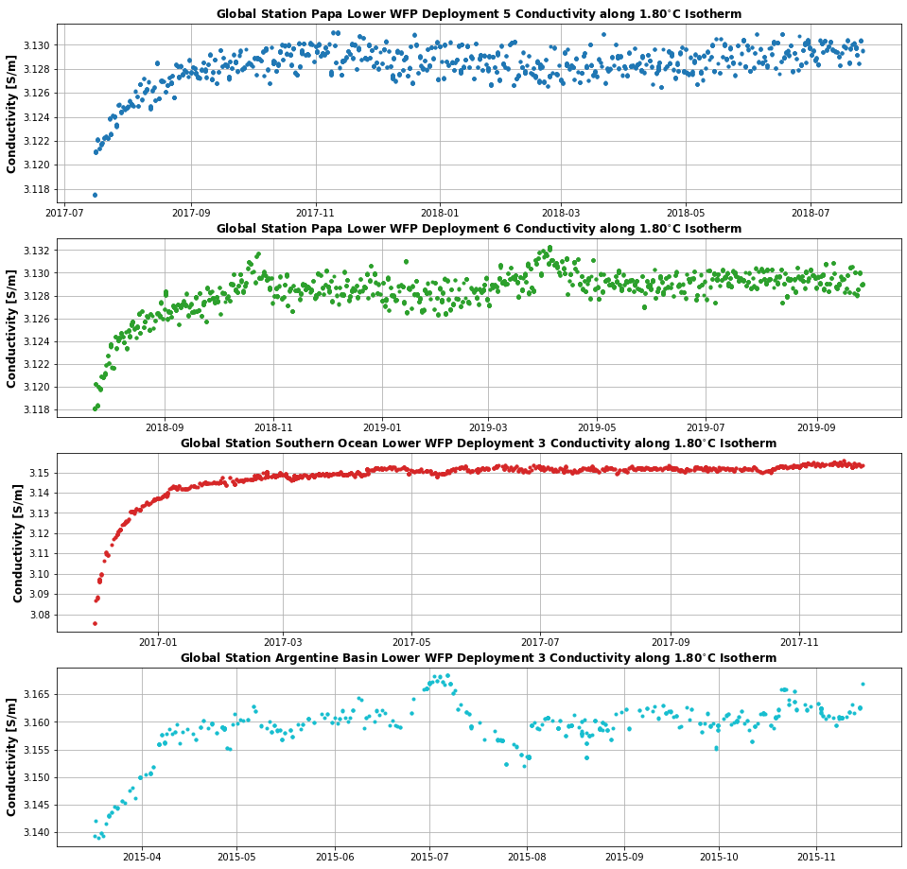

# Background Conversation with SeaBird Instruments indicated that this is a previously identified problem and was first observed in Argo float data. The cause of the conductivity offset is fouling of the conductivity cell by the Tributyl Tin anti-fouling capsule. SeaBird suggests that if the TBT capsule is not thoroughly dried before shipping, the TBT will form a viscous film over the conductivity cell. The film is subsequently washed-away once the instrument is deployed. This explains the decaying exponential curve behavior in the offset. Additionally, the requirement that the TBT not be fully dried for this effect to occur explains the irregular occurrence.

# Model We start be describing the observed conductivity by the GWFP as a simple equation where the measured conductivity is equal to the actual seawater conductivity and some offset: observations = seawater conductivity + deltaC + error Based on conversations with SeaBird, the offset in conductivity is likely a physical interference effect of the TBT anti-fouling agent and that the size of the offset is proportional to the concentration of TBT. At the start of the deployment the concentration of TBT is at its largest in the conductivity cell. Once the deployment starts, the conductivity cell is flushed with water and the initial concentration of TBT decreases in proportion to the flushing. We can model the TBT interference and flushing as an exponential function: $Δ_{TBT}=α∗{\left[TBT\right]}_{0}exp\left({−t}/τ\right)$ where deltaTBT is the conductivity offset due to TBT interference, [TBT]0 is the initial concentration of TBT, alpha is an interference factor of TBT with conductivity (expressed in units of mS/cm per unit of TBT), and tau is the flushing rate of water. Assuming that alpha is a constant, we can simplify this equation to: $Δ_{TBT}\left(t\right)=Δ_{TBT}\left(t=0\right)∗exp\left({−t}/τ\right)$ This model describes a conductivity interference due to TBT that is greatest at time t=0 and decreases exponentially as a function of the flushing rate until the TBT interference is zero. At that point the conductivity cell should be measuring the seawater conductivity free of TBT interference. We can take the modeled interference of the TBT and subsitute that back into our original equation so that we have: Condmeasured(t) = C(t) + alpha*deltaTBT*exp(-t / tau) + error where as t → inf, the interference term goes to zero, and thus the measured conductivity becomes the actual seawater conductivity plus measurement error. Importantly, the inteference/offset of the TBT does not contribute to the measurement error because its effect is on the estimate of the mean. Consequently, we can

# **Methods** Since we do not to be concerned about the contribution of the TBT interference to the error term, we can calculate the TBT offset thanks to the

# **Deconvolution**

# Title/Subject>

## Subsection Title <Overview if appropriate>

<Insert text, tables, bullet lists, or figures and/or subsections as may be appropriate here>

Table 4‑2 <Table Title>

|  |  |  |  |  |
| --- | --- | --- | --- | --- |
| **Header** | **Header** | **Header** | **Header** | **Header** |
|  |  |  |  |  |
|  |  |  |  |  |
|  |  |  |  |  |
|  |  |  |  |  |



Figure 4‑1 <Figure Title>

* Item 1
* Item 2
* Item 3

### Subsection Title

<Insert text, tables, bullet lists, or figures and/or subsections as may be appropriate here>

## Subsection Title <Report Conclusion if appropriate>

<Insert text, tables, bullet lists, or figures and/or subsections as may be appropriate here>

Table 4‑3 <Table Title>

|  |  |  |  |  |
| --- | --- | --- | --- | --- |
| **Header** | **Header** | **Header** | **Header** | **Header** |
|  |  |  |  |  |
|  |  |  |  |  |
|  |  |  |  |  |
|  |  |  |  |  |



Figure 4.2‑2 <Figure Title>

* Item 1
* Item 2
* Item 3

### Subsection Title

<Insert text, tables, bullet lists, or figures and/or subsections as may be appropriate here>

#### Appendix A - <Appendix A Title>

<Insert Appendix A here>

#### Appendix B - <Appendix B Title>

<Insert Appendix B here>